Measures and Cards

Consider the source file Sales_Data.xlsx.

1. **Card 🡪** One Aggregation can be put in one card, because card has a single value number, i.e. a single measure.

**Place a Card and simply put Cost in that.** We will get the total sales done till now.

The value is **119M**.

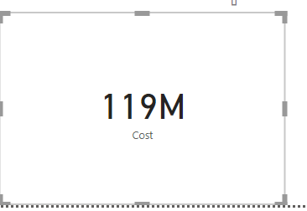

If you want to show the exact value then

* Select that card first
* Select its properties (brush or roller icon)
* **Data Label**
* **Display Units** 🡪 By default is Auto
* Change the Display Units to **None** as shown next 🡪

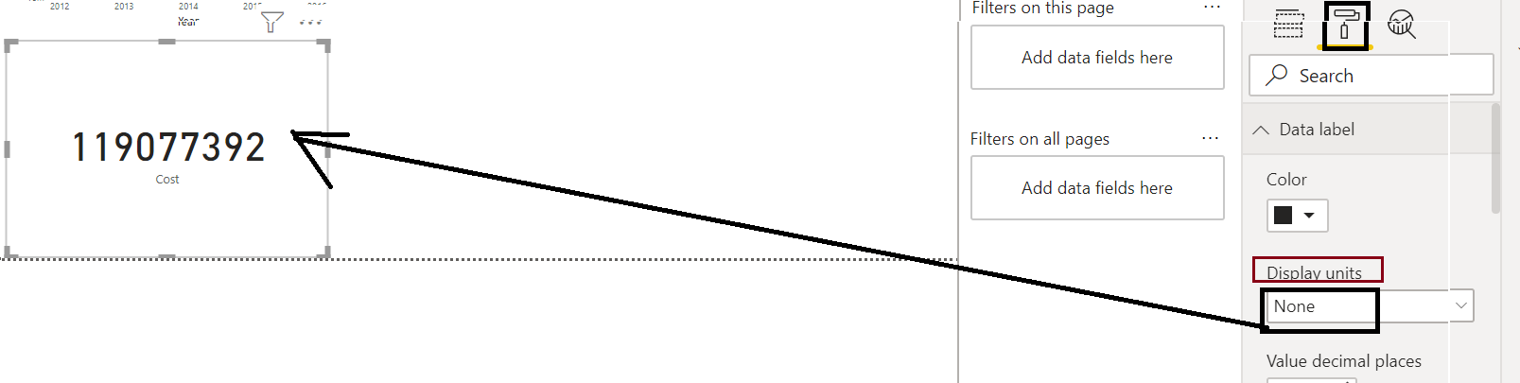

1. **Multi-row card 🡪** Suppose we have many measures to show. Then putting each one by one in Card is tedious. Instead of that we can put multiple measures in a single Multi-row Card.

Let’s create the below 4 measures:

M_Sum of Qty = Sum(Sales[Qty])

M_Average of Cost = AVERAGE(Sales[Cost])

M_Max of Cost = Max(Sales[Cost])

M_Min of Cost = MIN(Sales[Cost])

Put a **Multi-row Card** and simply select the above 4 measures in it!!

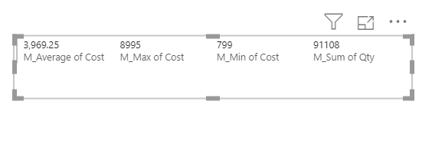

You can increase the Font Size for all the measures inside the Multi-row Card.

*** Resize the Multi-row Card and you can see that all gets arranged automatically!!!